Currency Converter App Test Results

Revision 1

CMSC 495 6380

July 2, 2021

Group 4

Roy Auh, Ronald DeSears, Stephen Snelling

**Revision History**

|  |  |  |  |
| --- | --- | --- | --- |
| **Revision Number** | **Date** | **Description** | **Name** |
| 1 | 7/2 | Creation of document | Roy |

**Test Case 1:** Startup of application

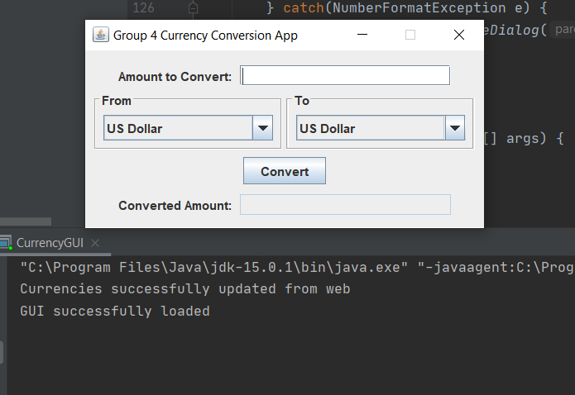

**Test Case 2:** User initiated termination of application

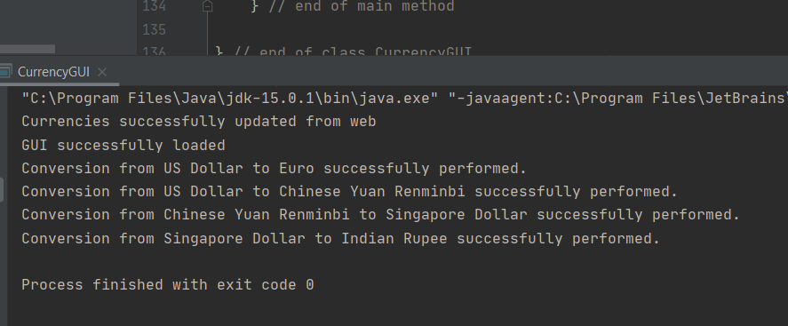

**Test Case 3:** Currency type selection and execution of conversion after clicking the “Convert” button.

Currency 1: USD

Currency 2: Euro

Amount: 2

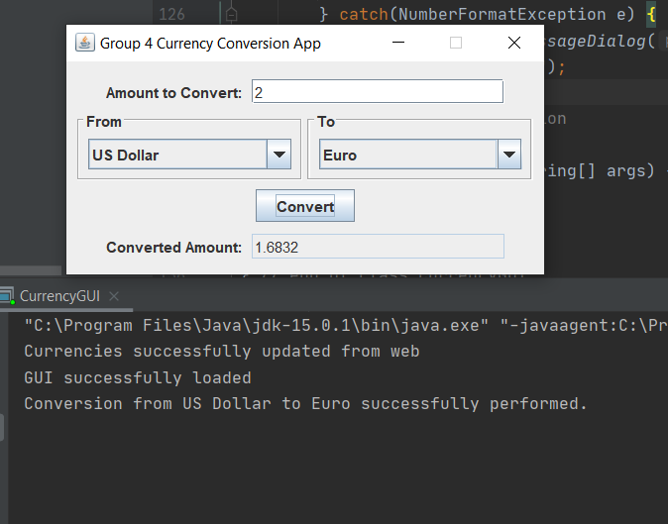

**Test Case 4:** Multiple Conversions from different selected currencies, showing the app can handle more than one conversion before termination.

*Conversion 1:*

Currency 1: USD

Currency 2: CNY

Amount: 100

*Conversion 2:*

Currency 1: CNY

Currency 2: SGD

Amount: 647.34

*Conversion 3:*

Currency 1: SGD

Currency 2: INR

Amount: 134.69

*Conversion 1:*

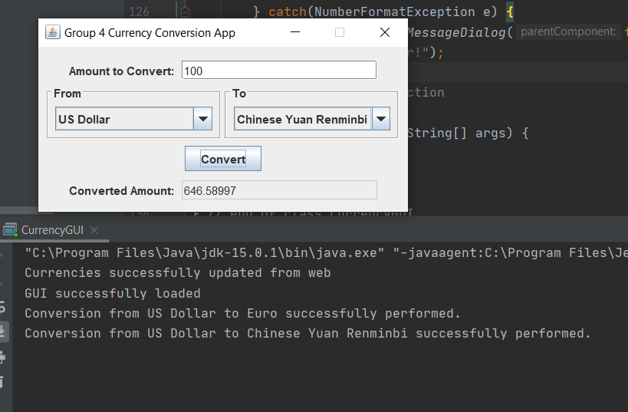

*Conversion 2: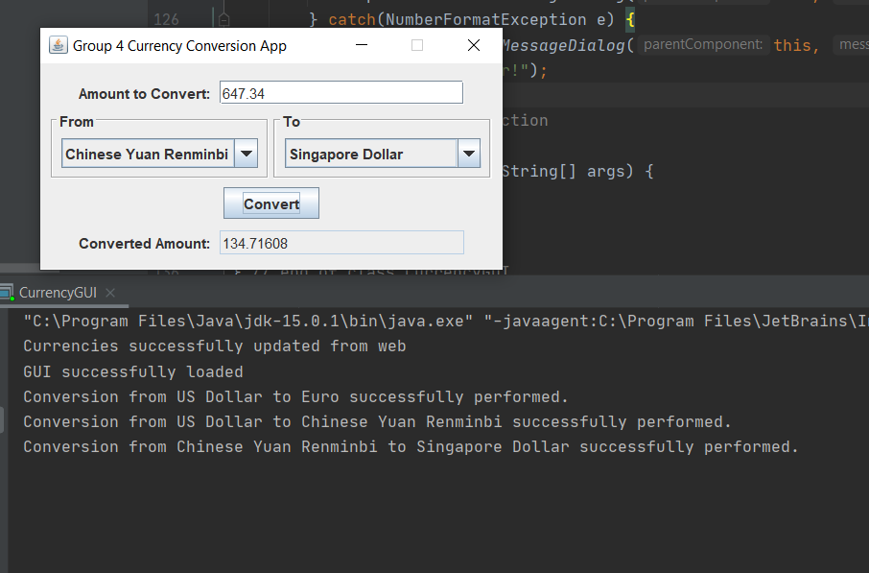*

*Conversion 3:*

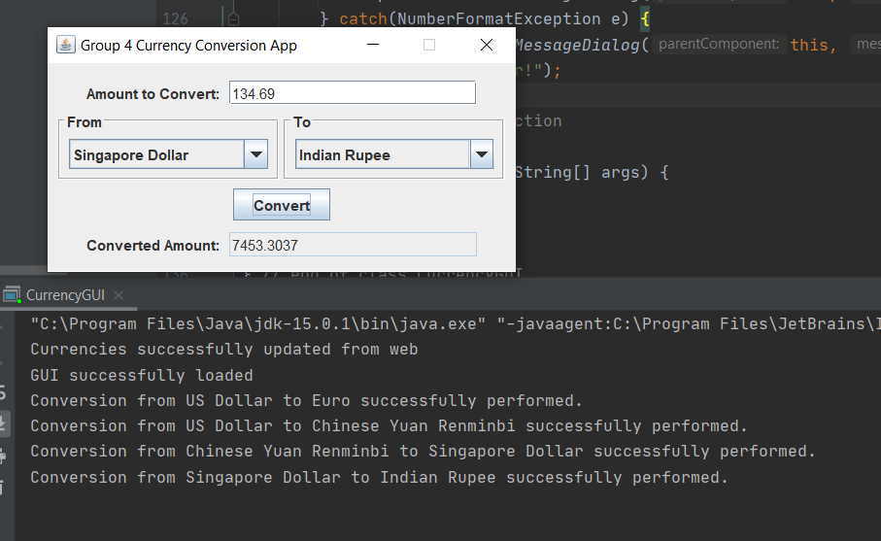

**Test Case 5:** User enters a negative currency value

Currency 1: USD

Currency 2: AUD

Conversion Amount: -150.5

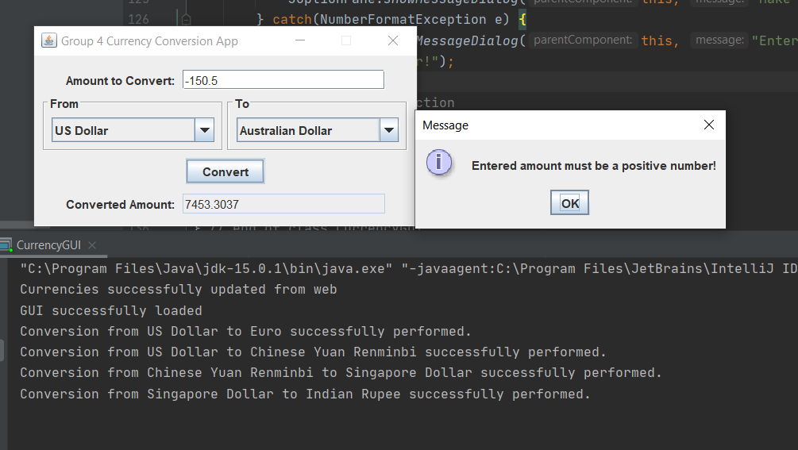

**Test Case 6:** User enters a non-number currency value

Currency 1: Euro

Currency 2: USD

Conversion Amount: 14a

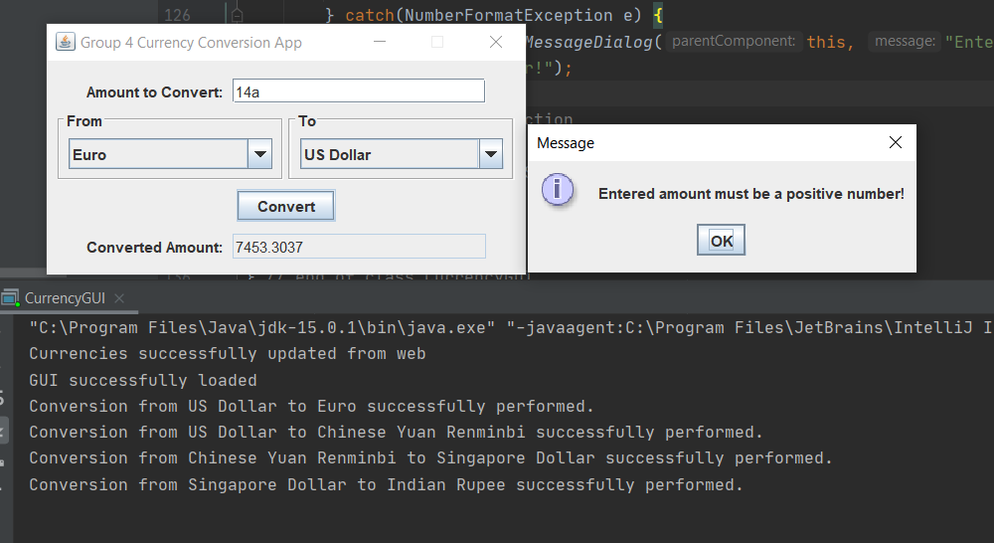

**Test Case 7**: Source website for currency rates unavailable

